Staying at Rest Experiment

1. Give at least three examples of objects that stay at rest in the absence of forces that might cause them to do something else. Seesaws, swings, and a jump rope.
2. Now give three examples of objects that normally do not stay at rest because some force is acting on them. Identify the objects and identify the force or forces that cause the object to change its state of rest. Volcanoes force is the heat building up which is thermal energy. Glaciers do not stay at rest because thermal energy melts them down. Geysers are caused from the heating of underground water by shallows bodies of magma which is thermal energy.
3. Gather Materials:
   1. One index card
   2. One coin
   3. One cup
4. Place a coin on the table in front of you. Watch it and make three observations. The coin is not moving which is potential energy. It reflects light from the ceiling. The coin is a flat circle and it has some ridges but it is smooth too.
5. Now place the coin on top of an index card that’s placed on top of a cup. Using your index finger, flick the index card from the side as shown below. With a bit of practice, you should be able to get the coin to fall into the cup while the index card flies away.

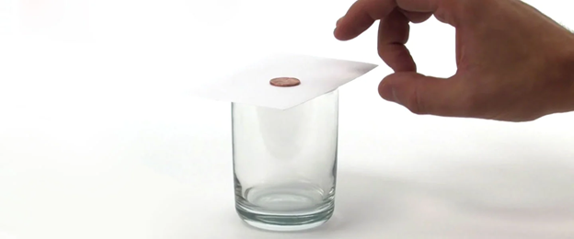

1. Explain why you think the card did what it did, and why the coin did what it did. I think the coin slides into the cup because when I flicked the index card it was light but the coin is heavier so it fell into the cup. But if the coin was lighter it would not go into the cup and it would go by the index card. That is why I think the coin did that.